

VueJS Task

**Student Name:   Pham Hong Phuc**

**Student ID:  001284212**

In this week report, with provision of the materials to do the assignment, I have learnt Vue.js – an open-source framework created from JavaScript to customize the webpage’s interface primarily. This is a brief image of the assignment that is done:

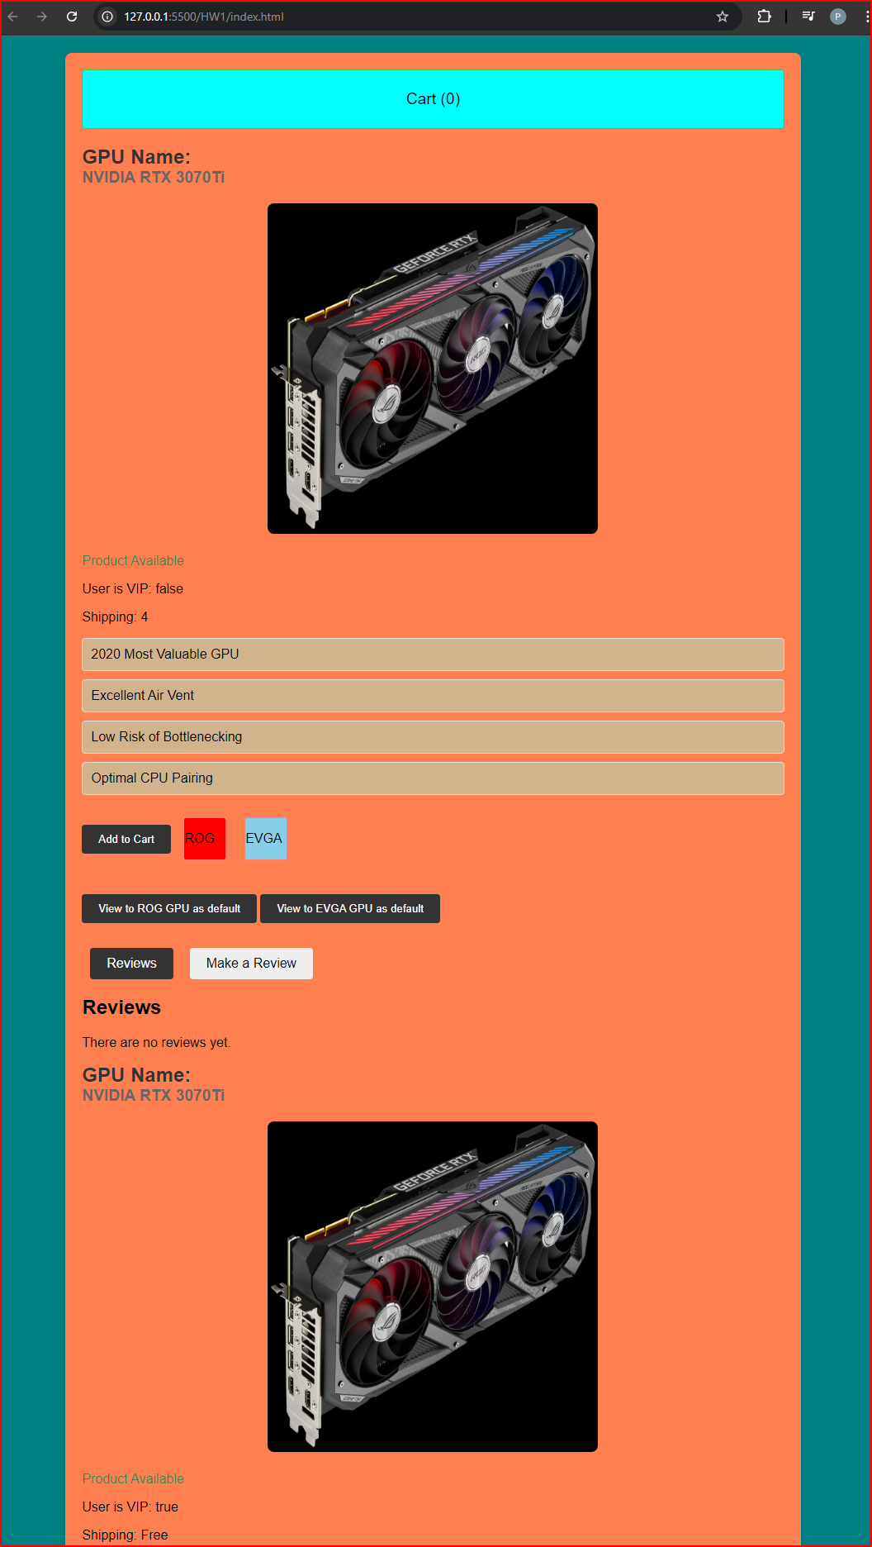

So in the Vue DevTools extension used, the raw data appeared to prove that how the page performs and works:

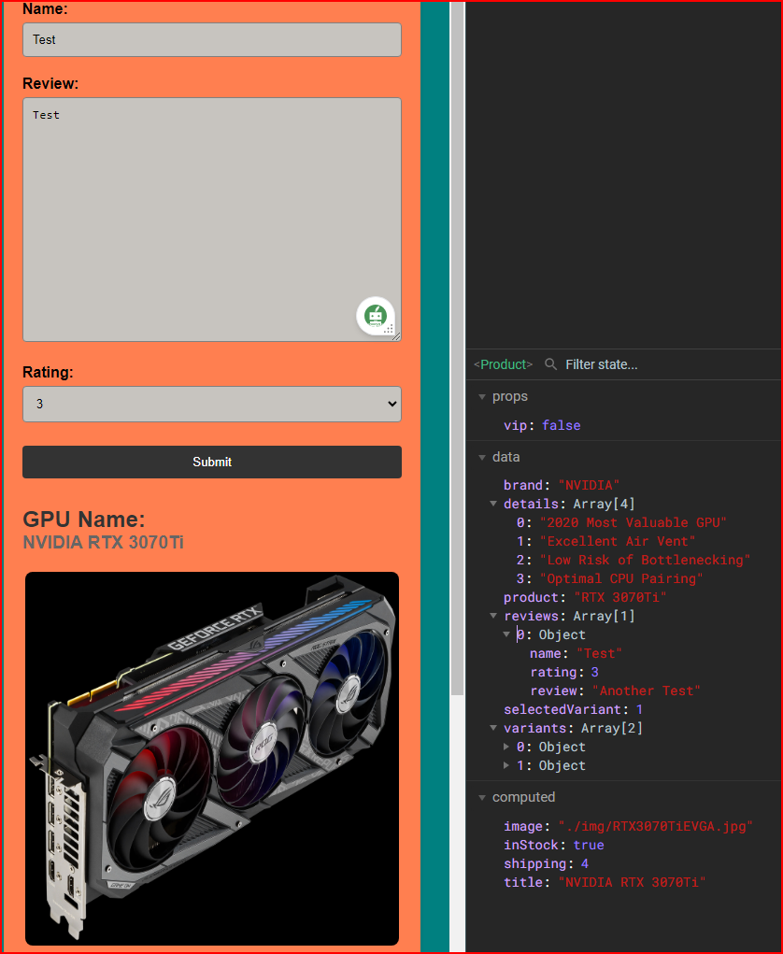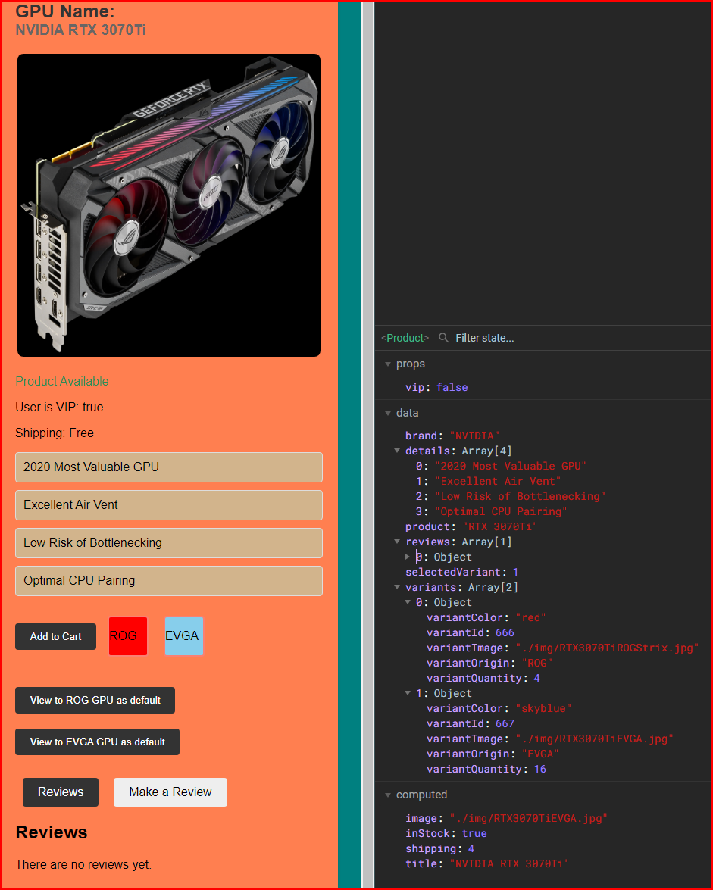

Starting with the Vue Mastery tutorials I have replicated and studied from, the raw codes and the results are shown below:

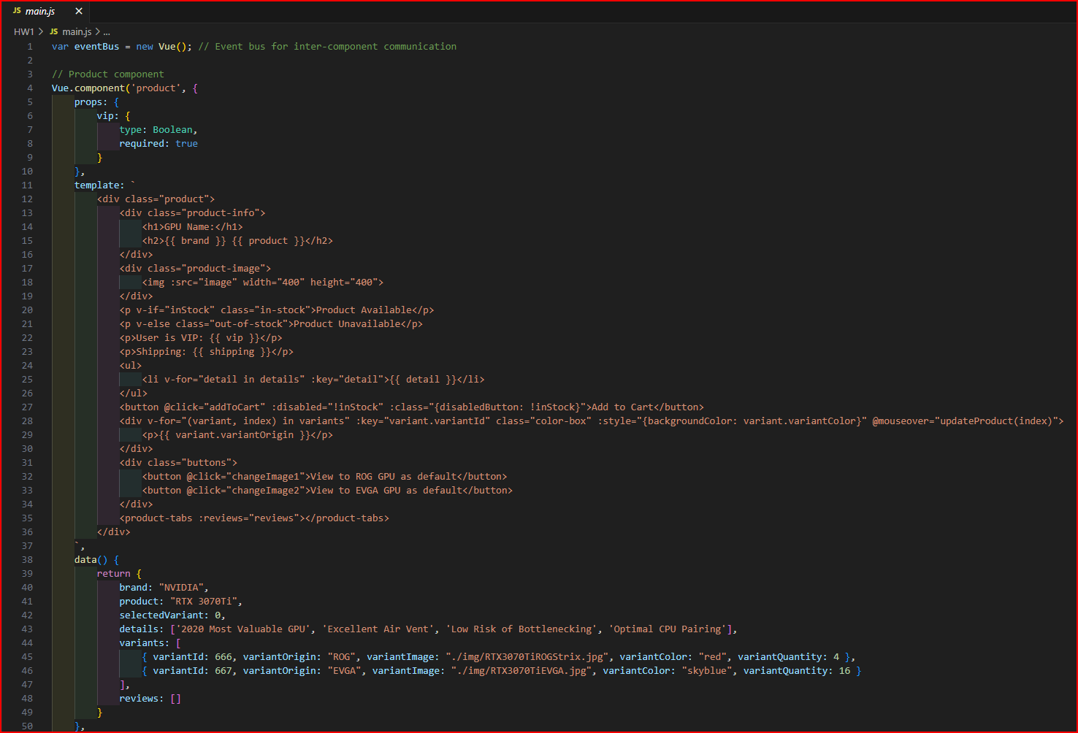

We have the main.js file to represent the back-end code to function all the important components created for the webpage basis (including the defined properties to import them on other files so as they run as a global variable in a single folder, reusable template that shows the replica version of an object the appeared on the screen.

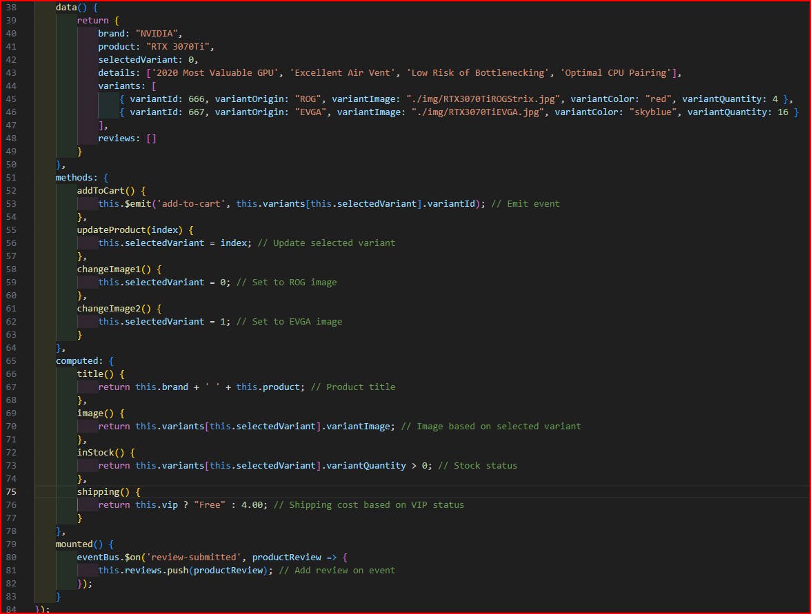

The following crucial features that is contained in the methods:

As expect to be seen, the webpage should load out certain files that defined from a directory is made for displaying purposes during the mouse hovering or pressing actions.



Then, a solid and simple function that act as an automated increment when clicking.

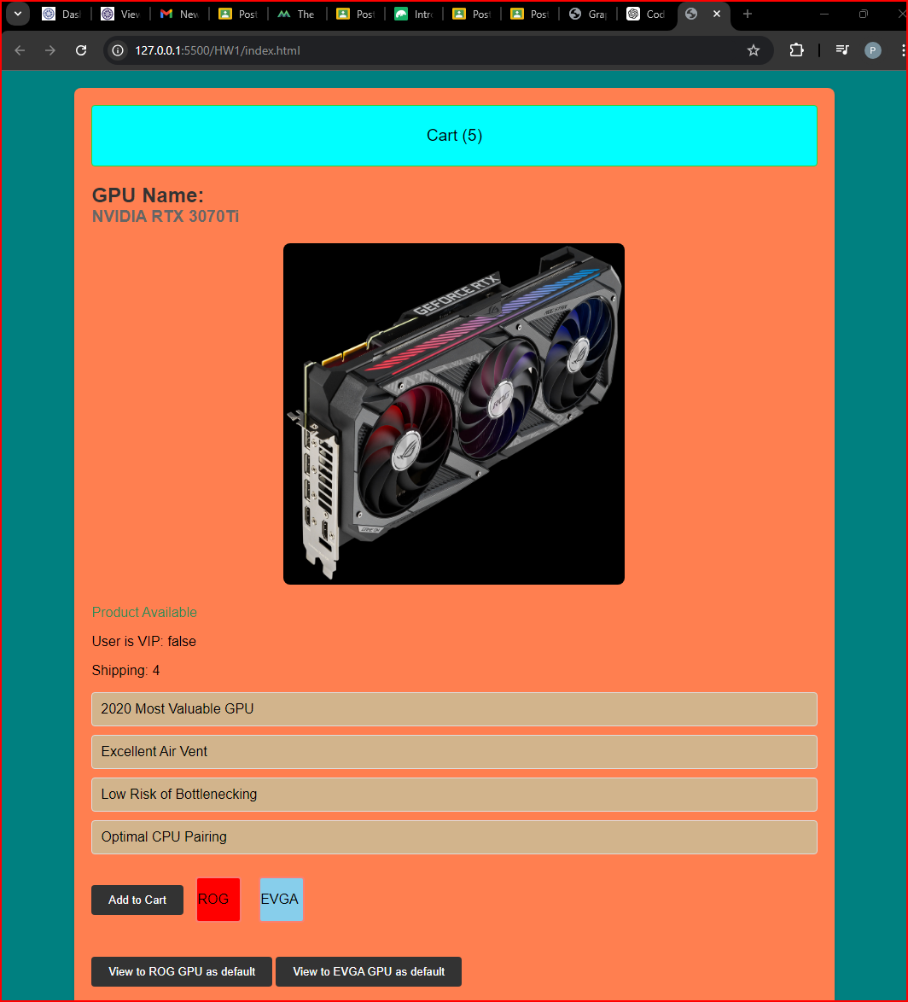

A conditional statement that is used to denote whenever the user is simulated to be special or not. Hence, the outcome is up to the condition declare when the status is set in Boolean state.

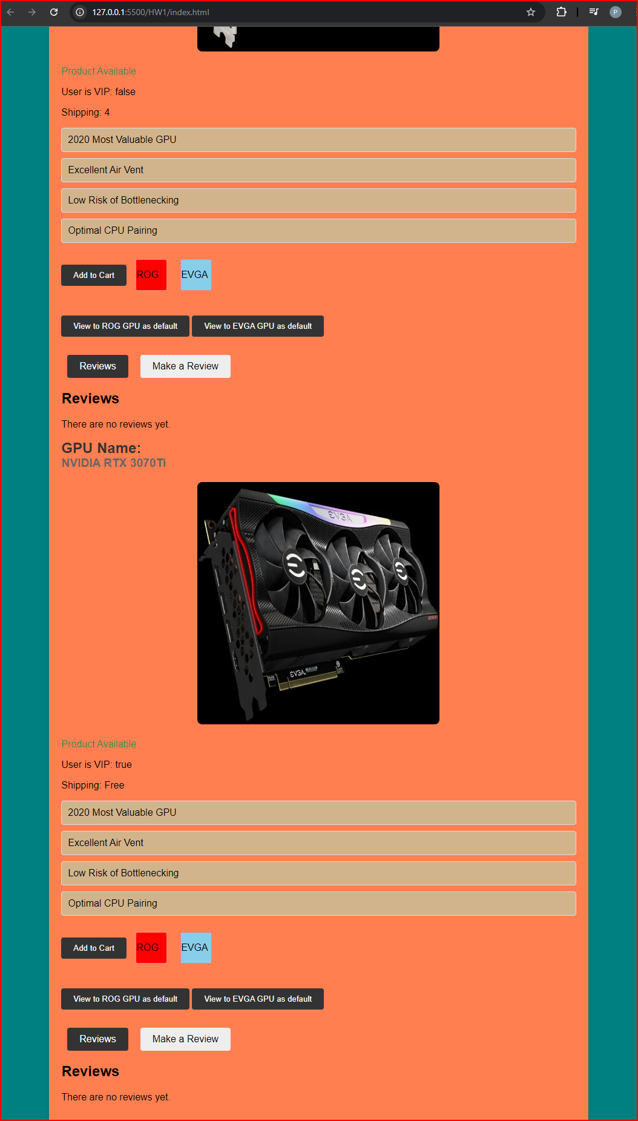

They encoded in the console display on Chrome (0 and 1):

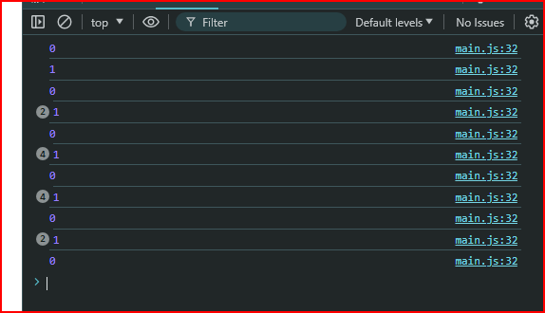

Upcoming feature:

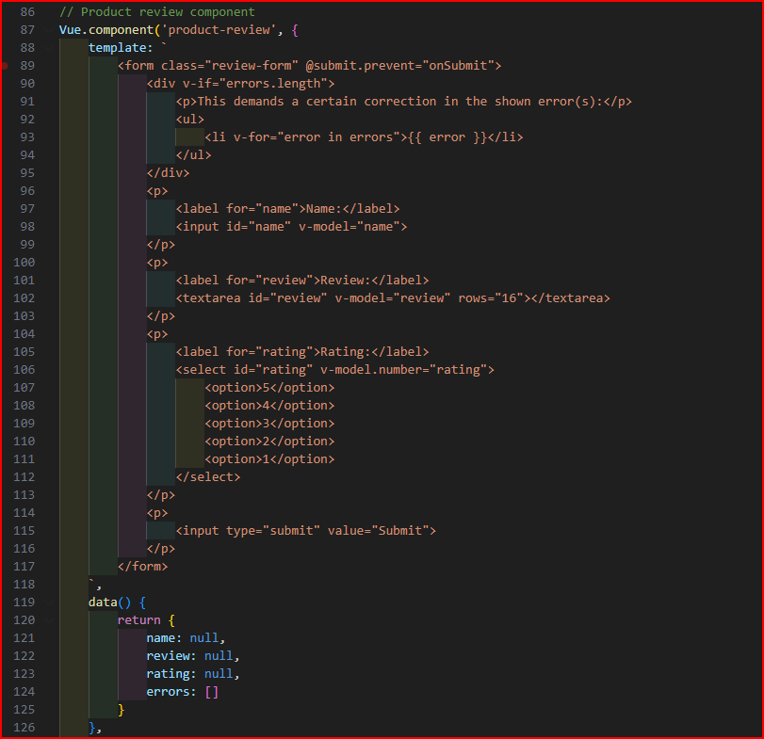

Next, we have a template of a writing form when performing a submission to save in the virtual root of Vue that is made of a vacant array to store up the data, temporarily.

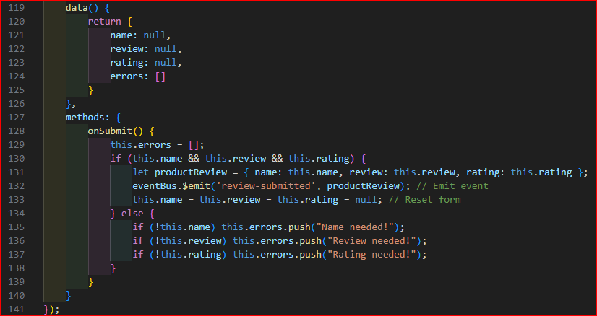

To specify the methods:

An empty array to accumulate textual data.

A cleared array to catch and throw errors what is missed during the form typing.

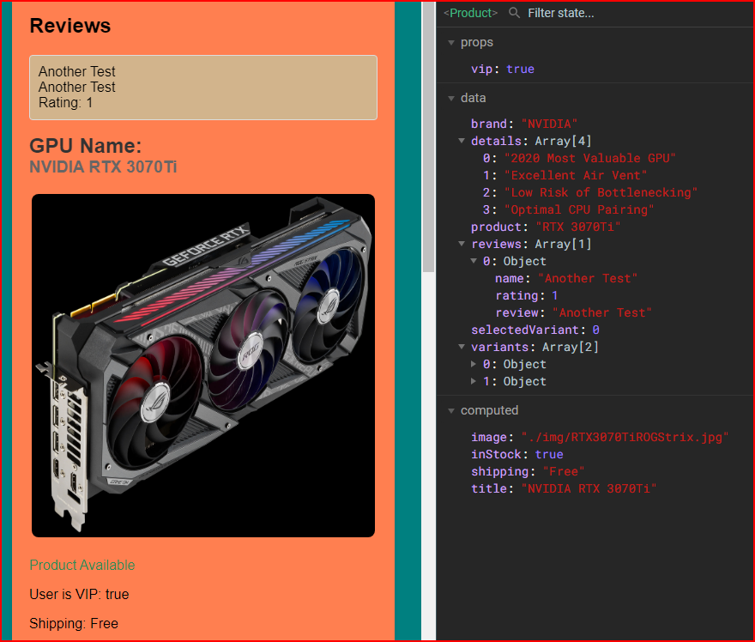

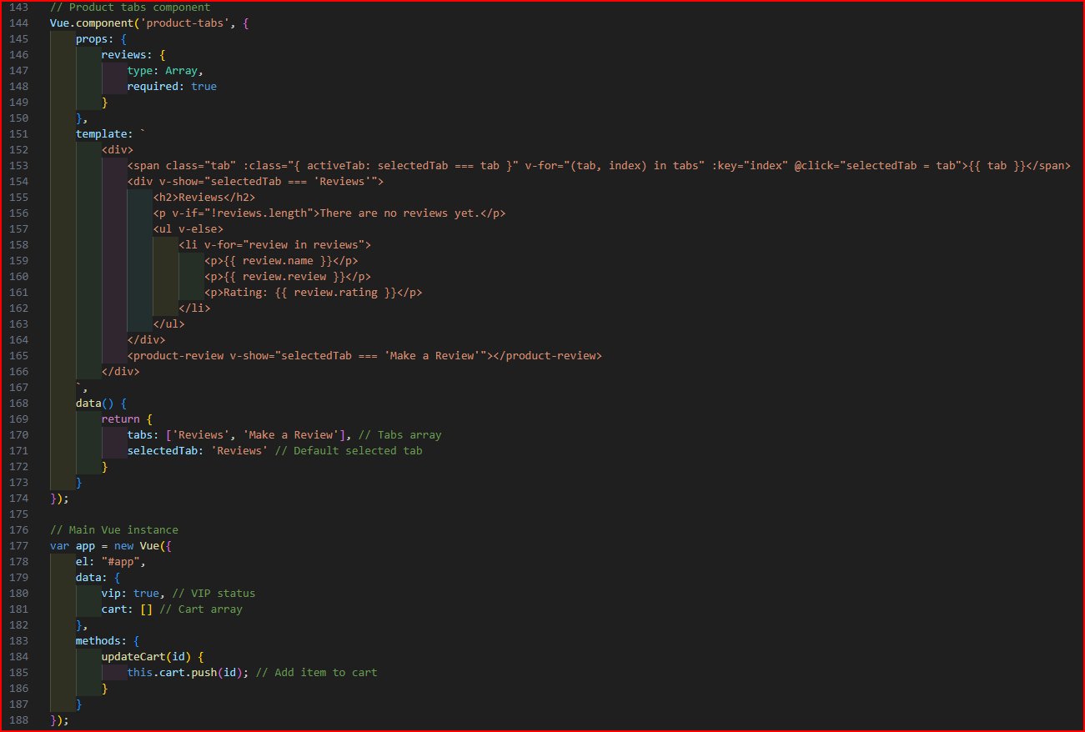

Lastly, we have a tab section to divide and show by using disable and transferring variable to show data on the page after the form activity proceed.

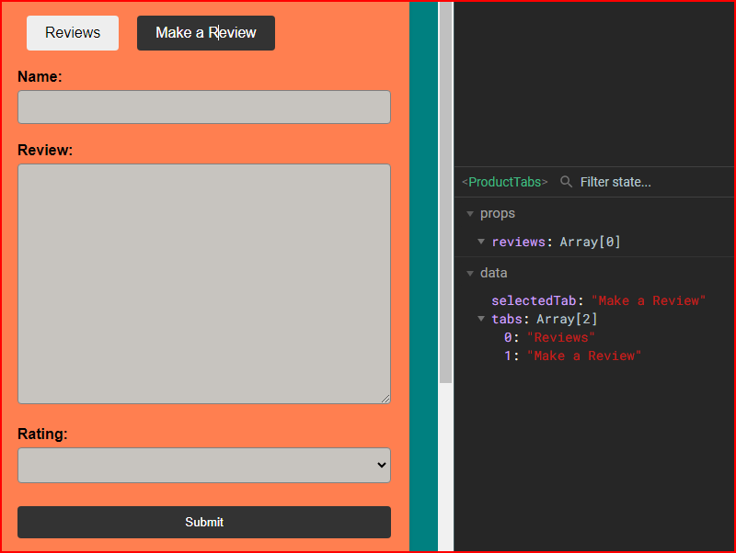

Finally, index.html and style.css codes for the web foundations:

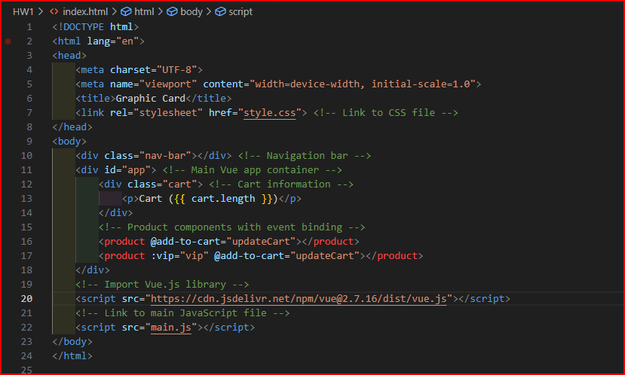

And an extra part:

